**Output Screenshots**

1. Suggest an appropriate solution so that your company can make use of cloud while keeping the requirements mentioned above for your company in mind

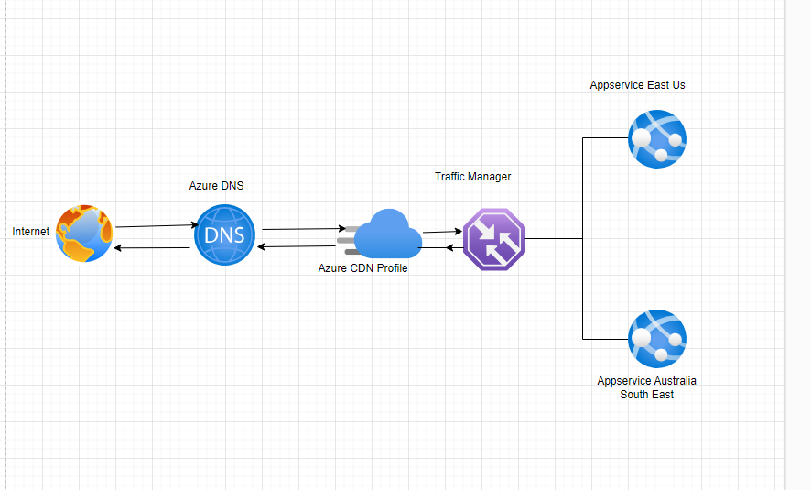

Recourses visualisation from Azure Portal

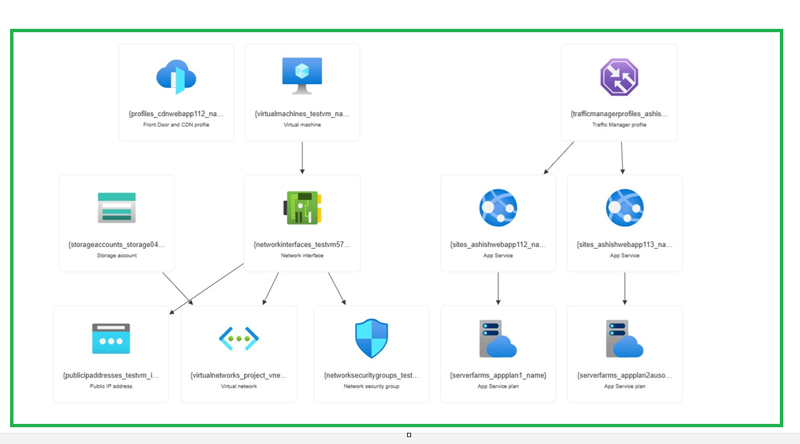

2. Provide an approach to:

a. Govern all the resources being used for development, testing, and production of the company’s web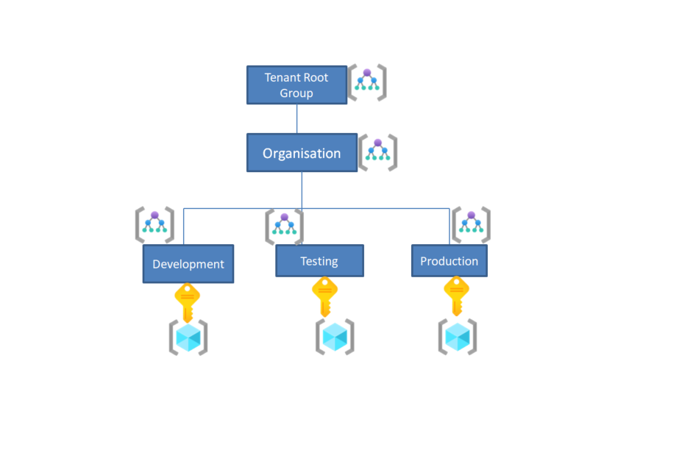

b. Keep a separate track of the billing life cycle and cost management of all the services being used for hosting the company’s website on Cloud

-For track of billing life cycle we can apply tags to the associated department also azure policies can be implemented to enforce tags on resources.

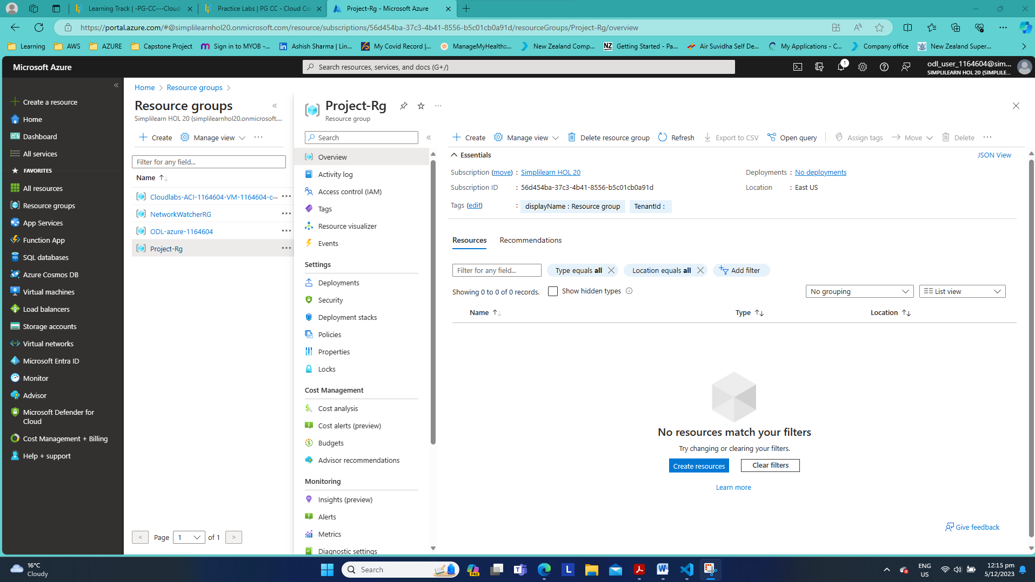

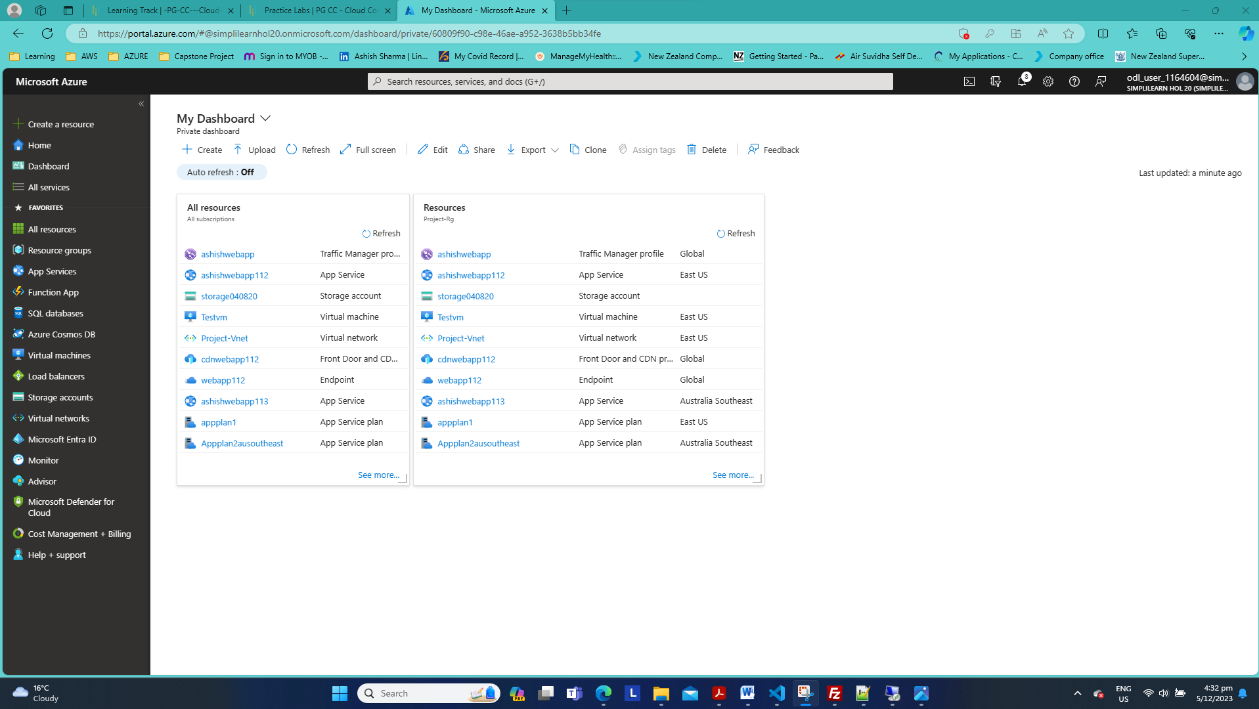

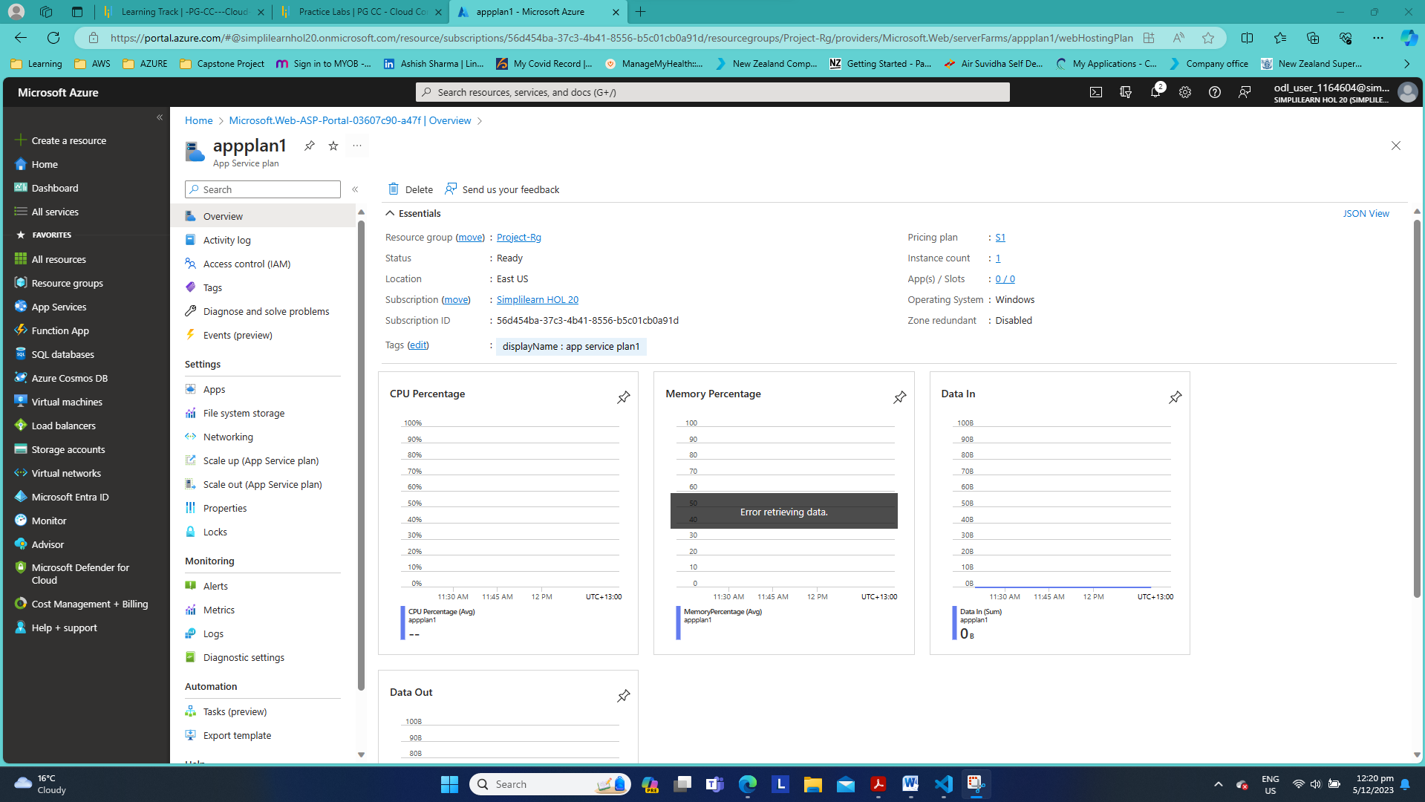

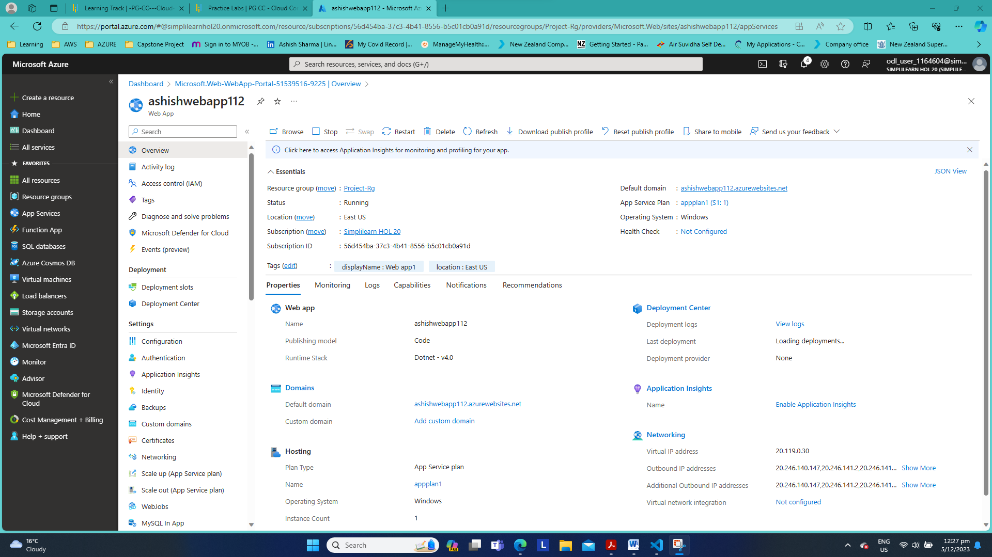

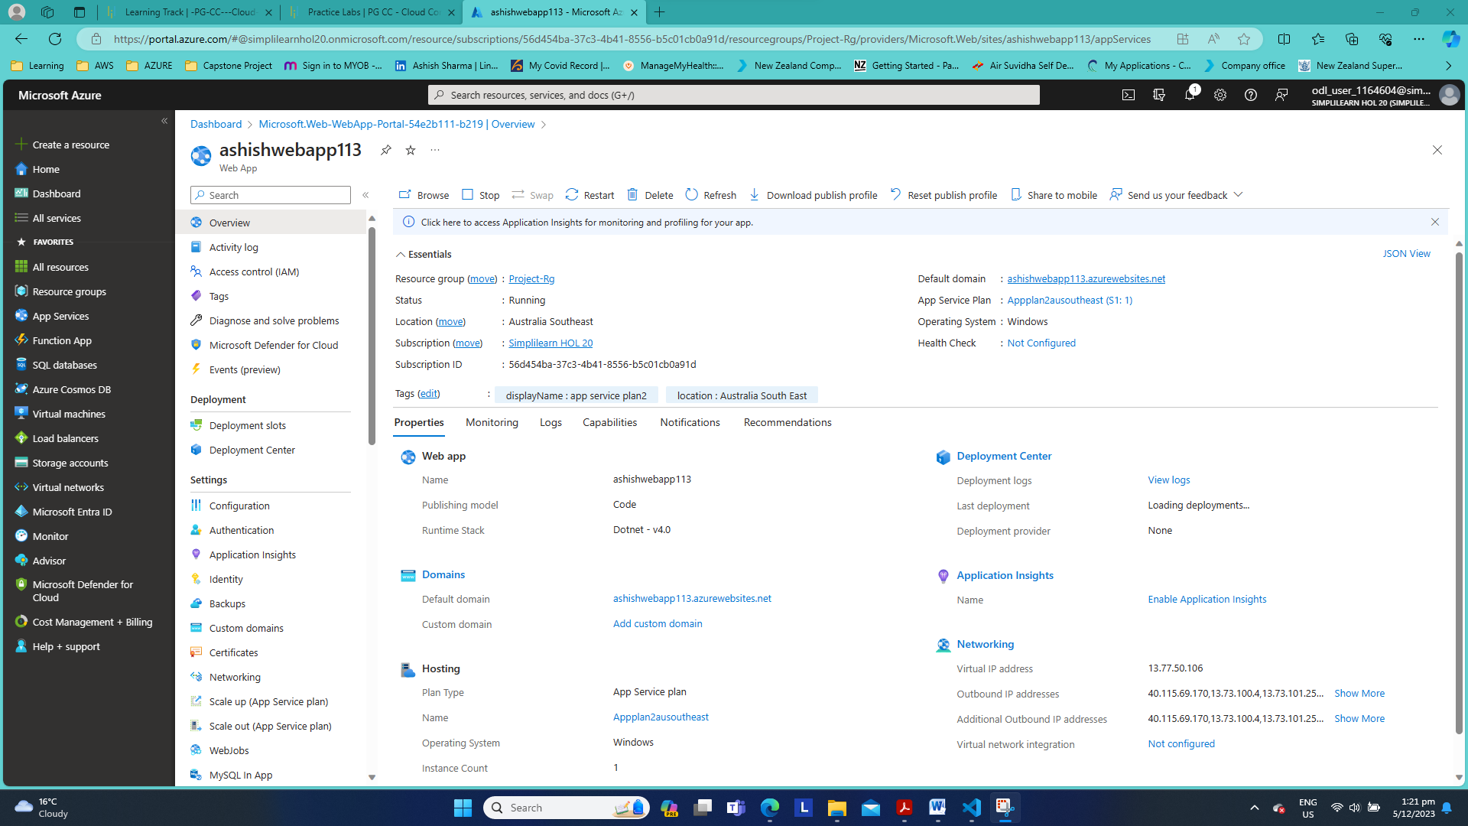

3. Upload all static content of your website to cloud

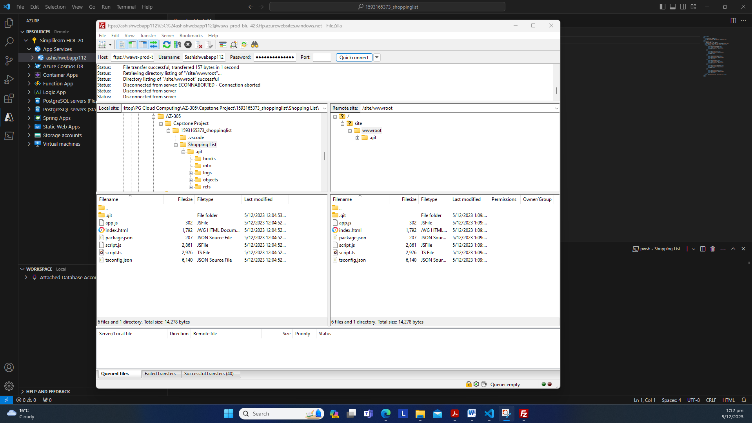

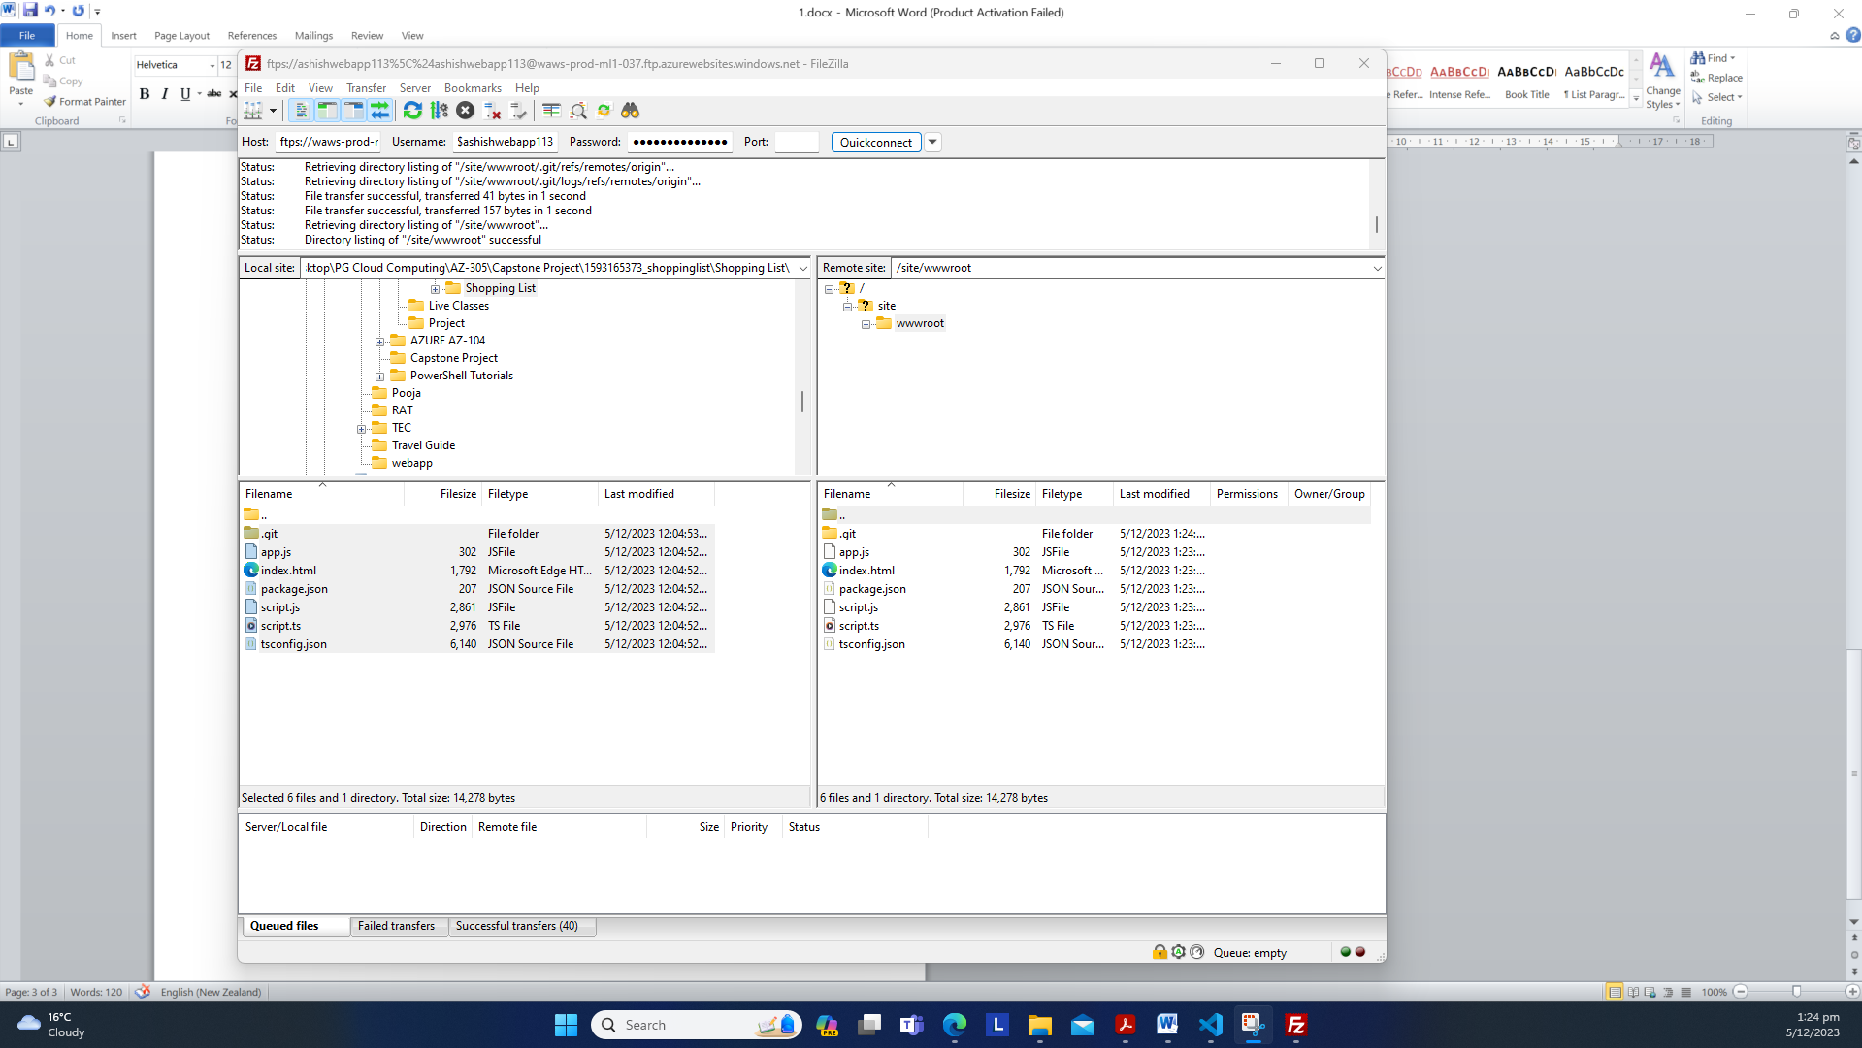





4. Create a CDN endpoint and configure it to serve the static files you have uploaded

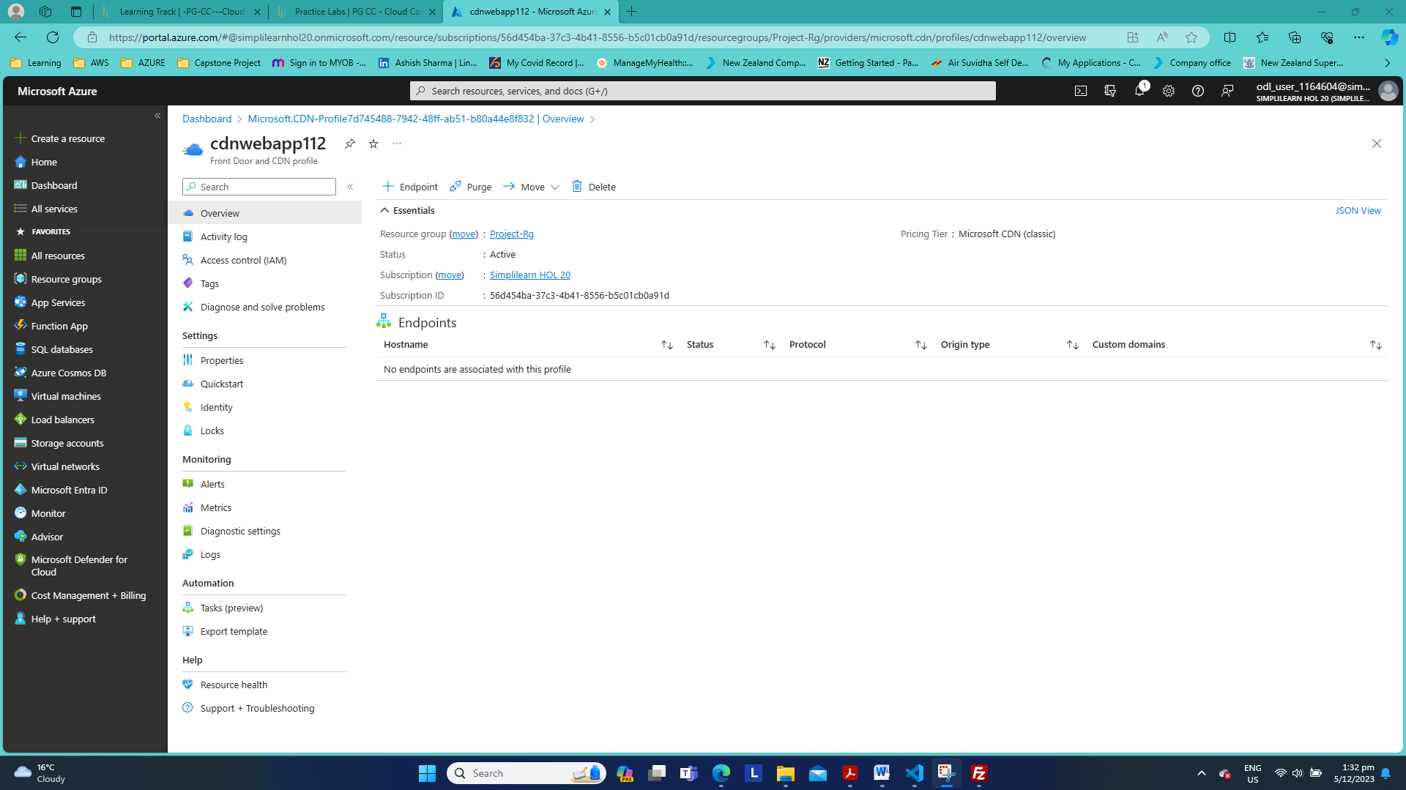

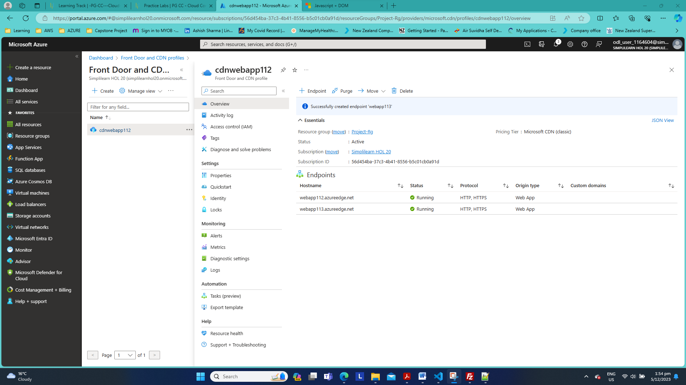

-Latency with origin hostname

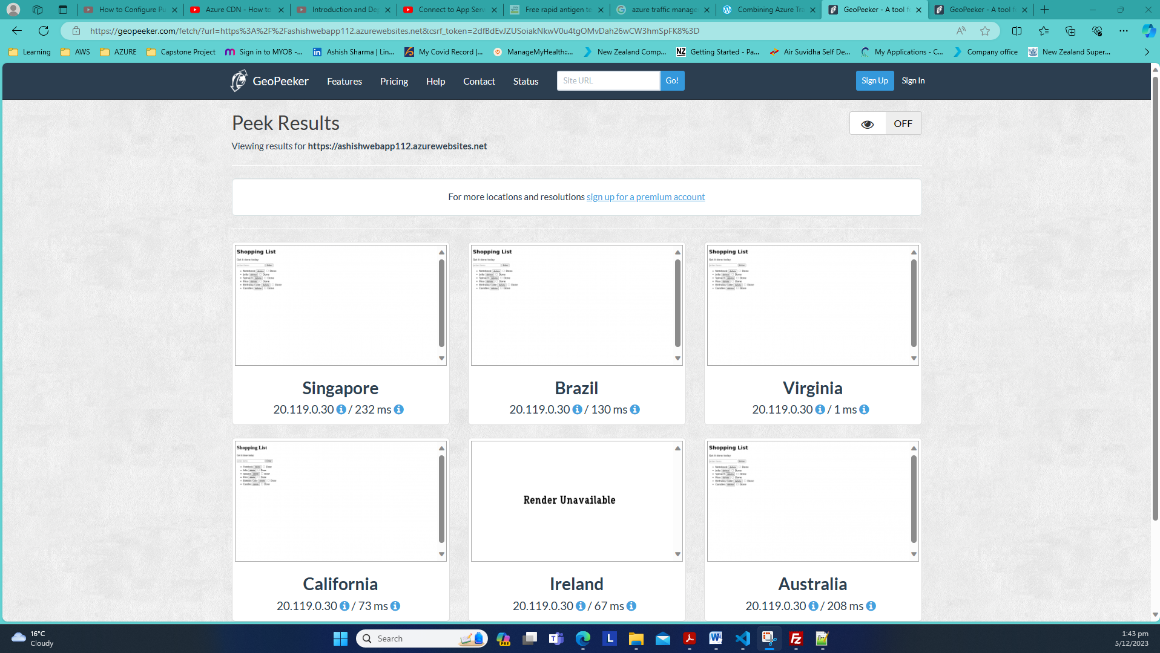

-Latency with the CDN edge location(Endpoint hostname)

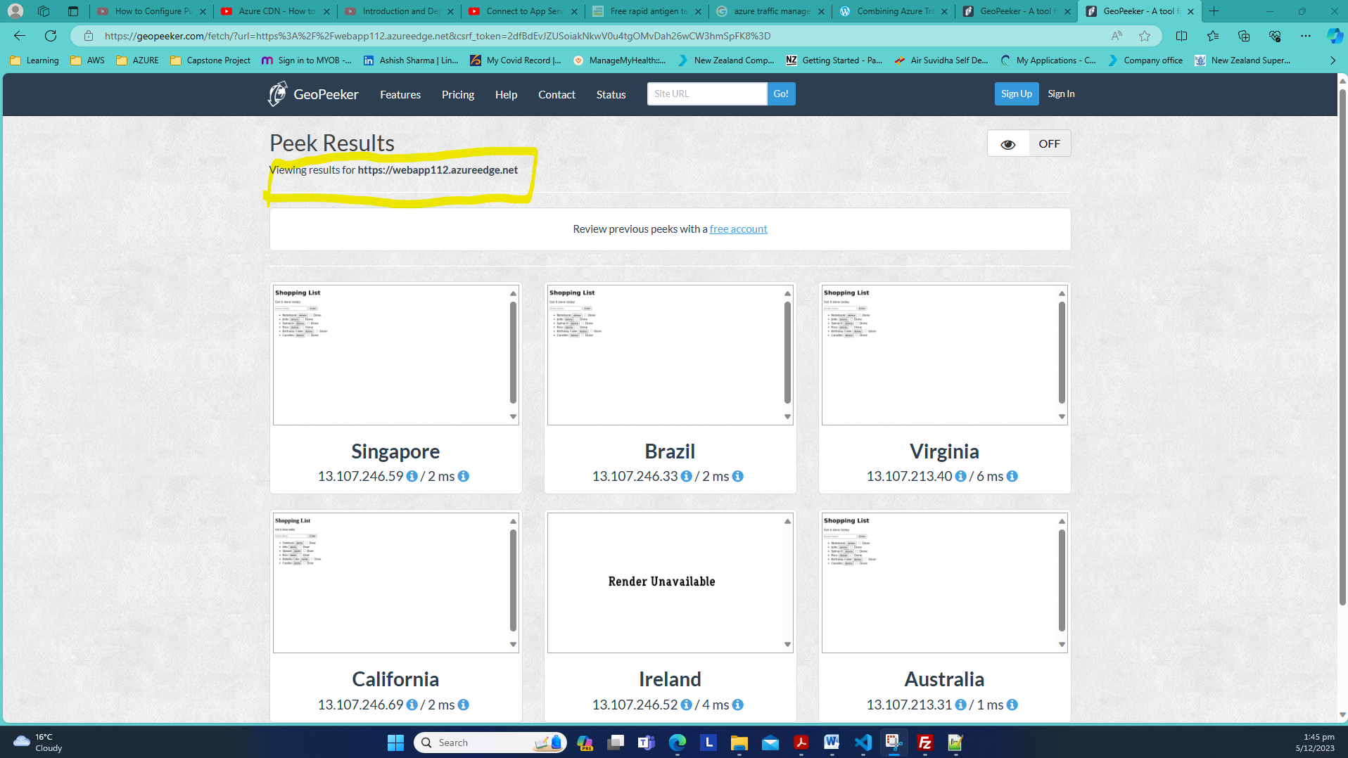

Traffic Manager

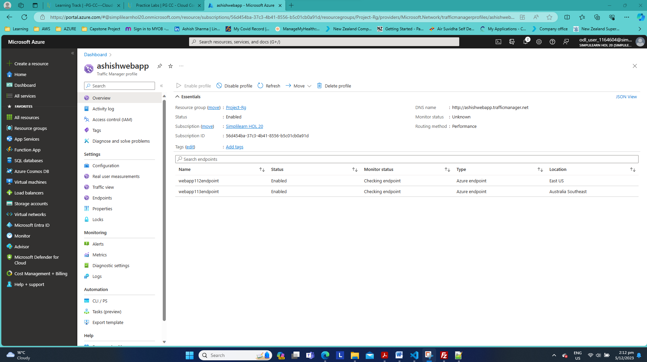



Stopped one web app and tried to access with its url [Web App - Unavailable (ashishwebapp112.azurewebsites.net)](https://ashishwebapp112.azurewebsites.net/)

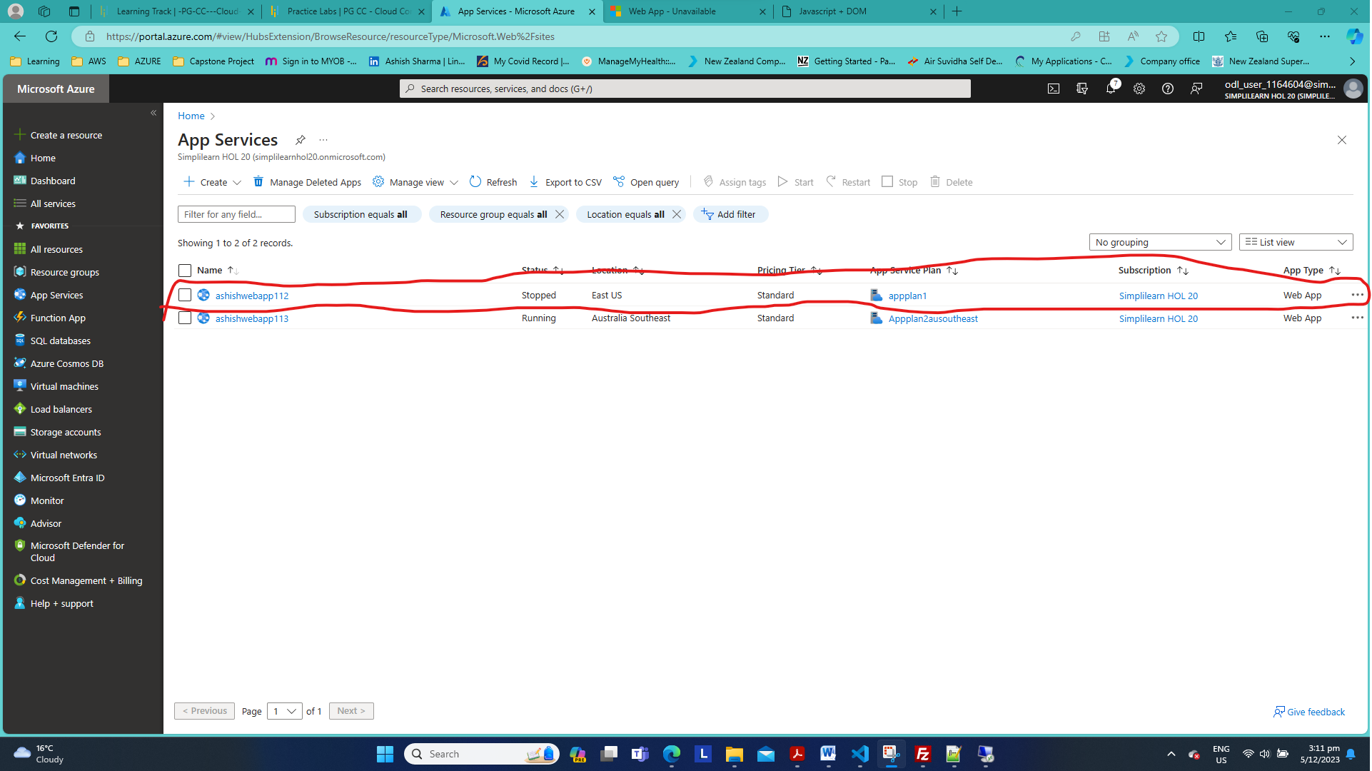



Confirmed Azure traffic Manager is rerouting traffic to the web app in Australia southeast



5. Use storage service and upload files for your teammates to share

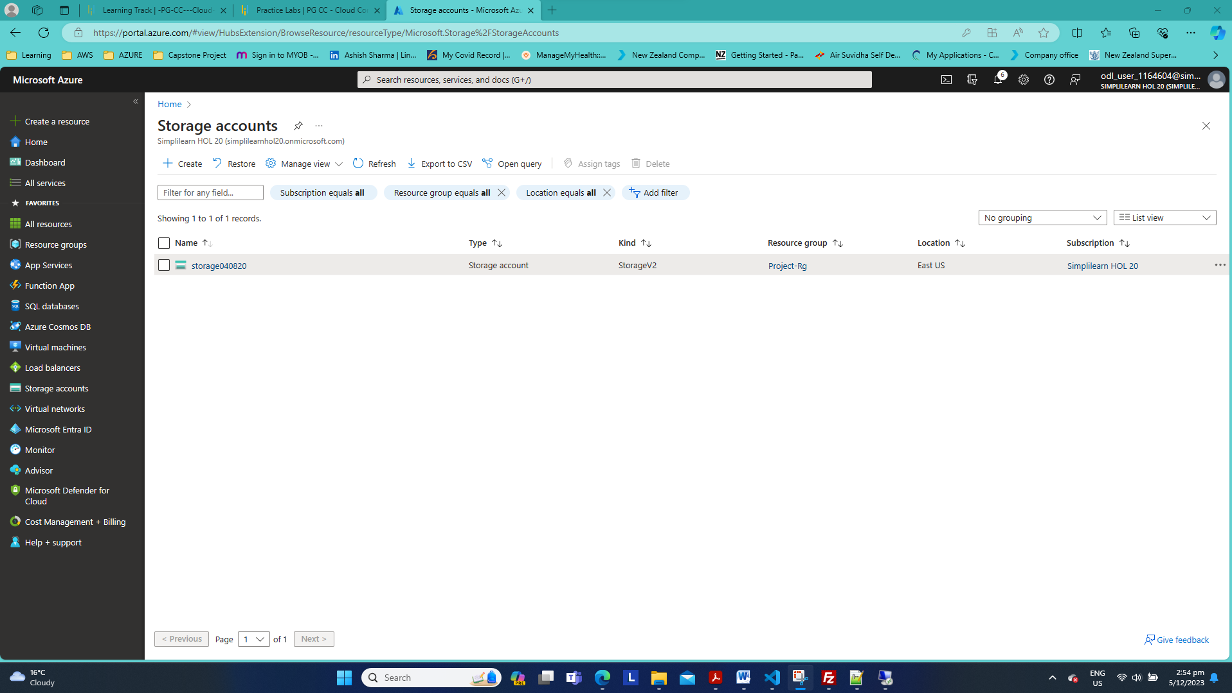

No Public access to this container

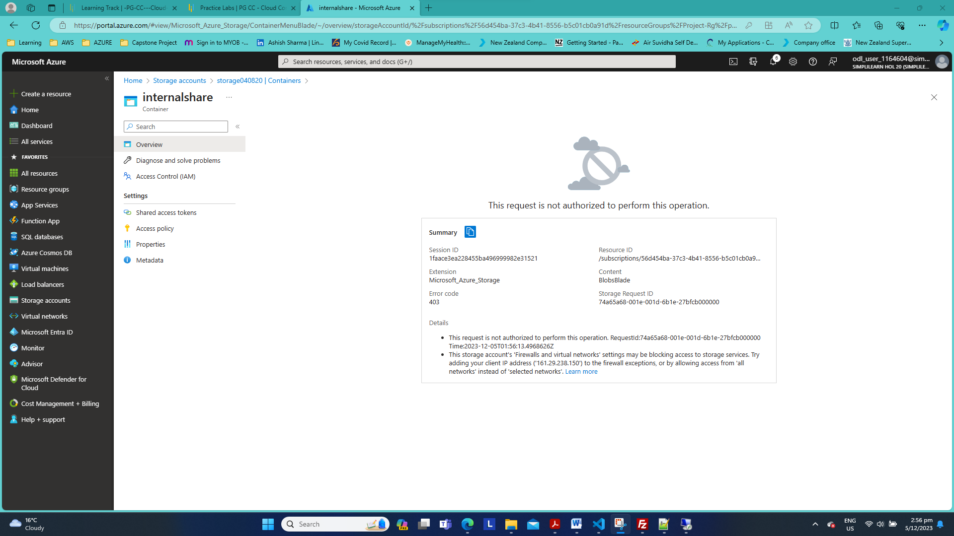

This storage account has private access which can only be accessed through Project V net.

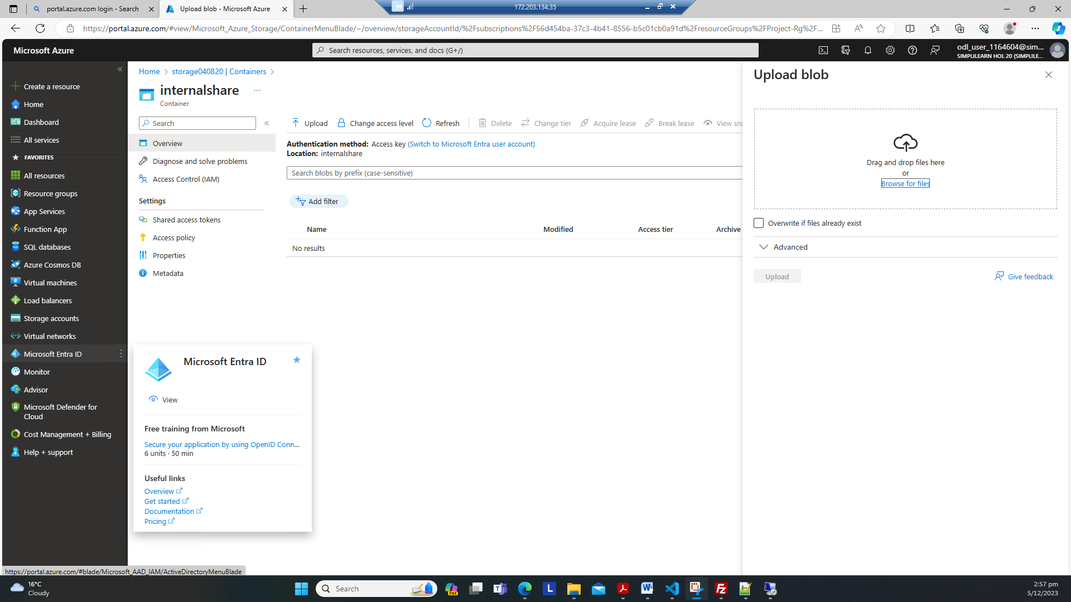

6. Connect Windows or Linux VM to the Storage service

